LOGIN SCREEN
https://prod.certcheck.in/login

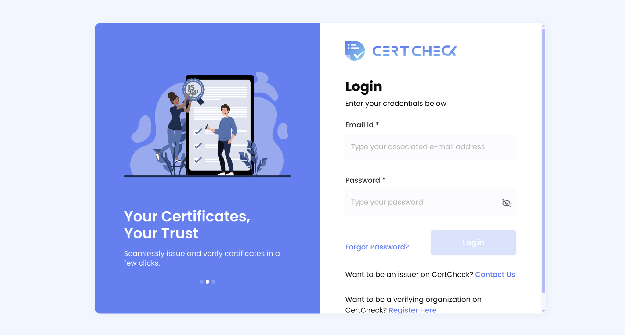

On this window,

- Microcopy can be improved-
- Type your associated email address can be replaced by enter registered email.
- Want to be an issuer on certcheck? Want to be a verifying organisation on CertCheck?
2. Scroll on the side can be avoided

ISSUER WINDOW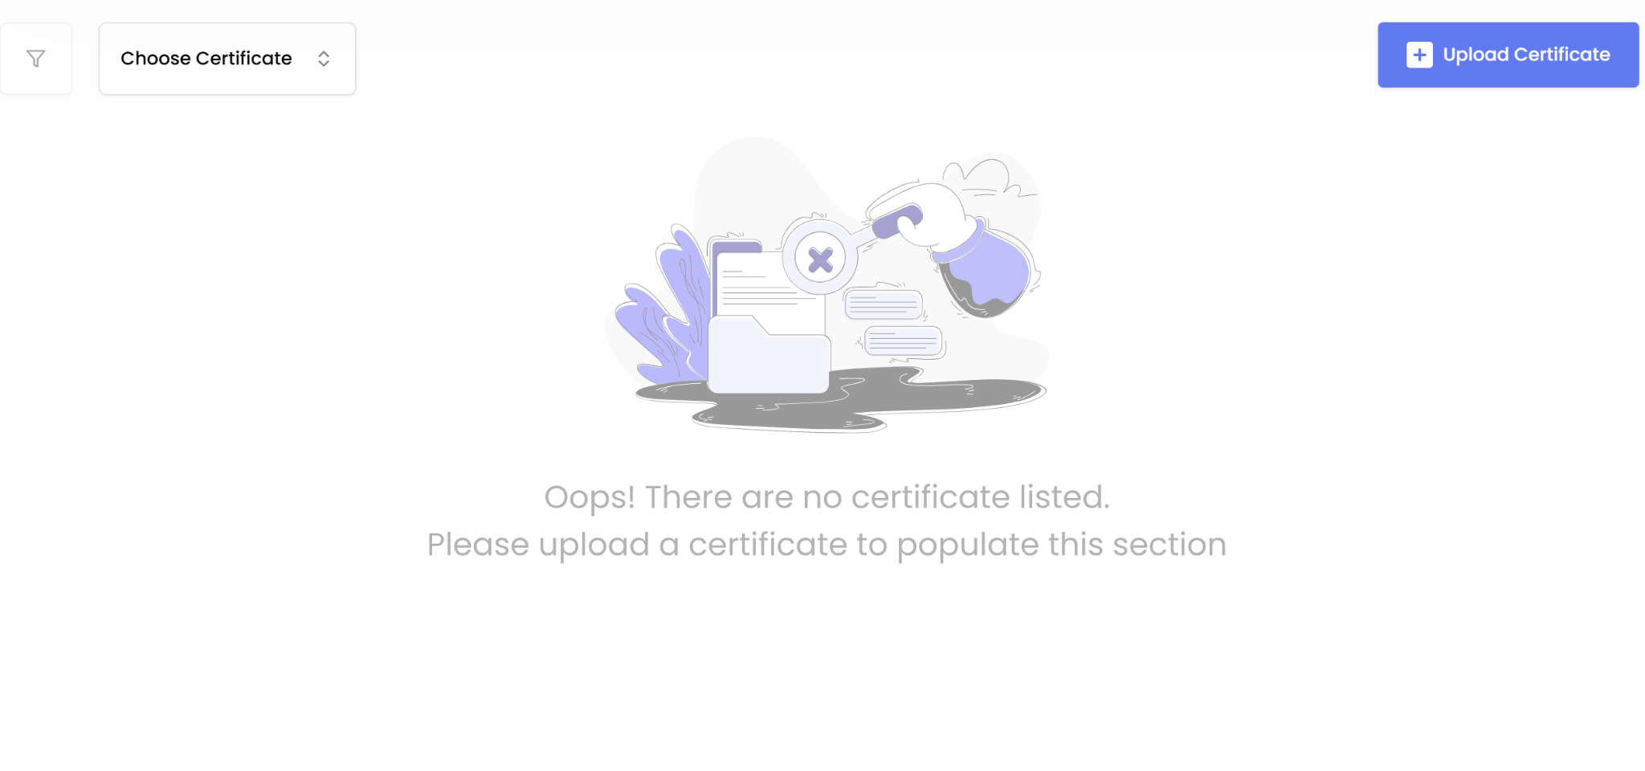

- Oops! Message can be replaced with a guide on how to upload certificates.
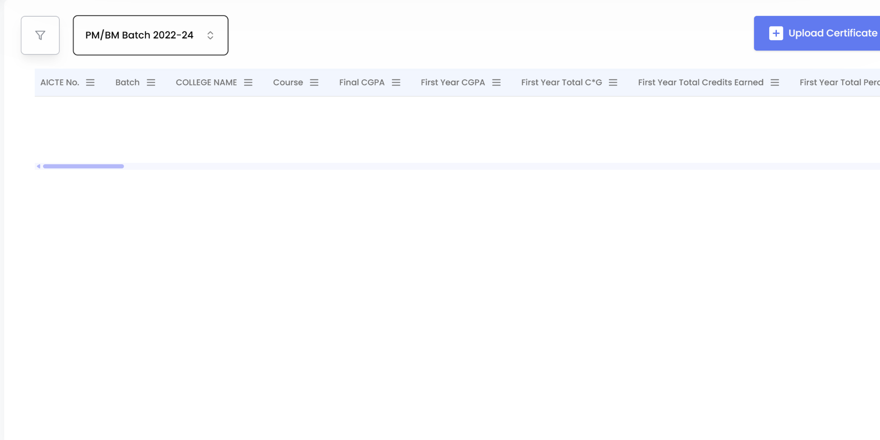

- After selecting “Choose Certificate”, although the filer icon blinks, it is not an intuitive step.
- Although the messaging says “Choose Certificate” it displays “Batch details”

VERIFIER WINDOW
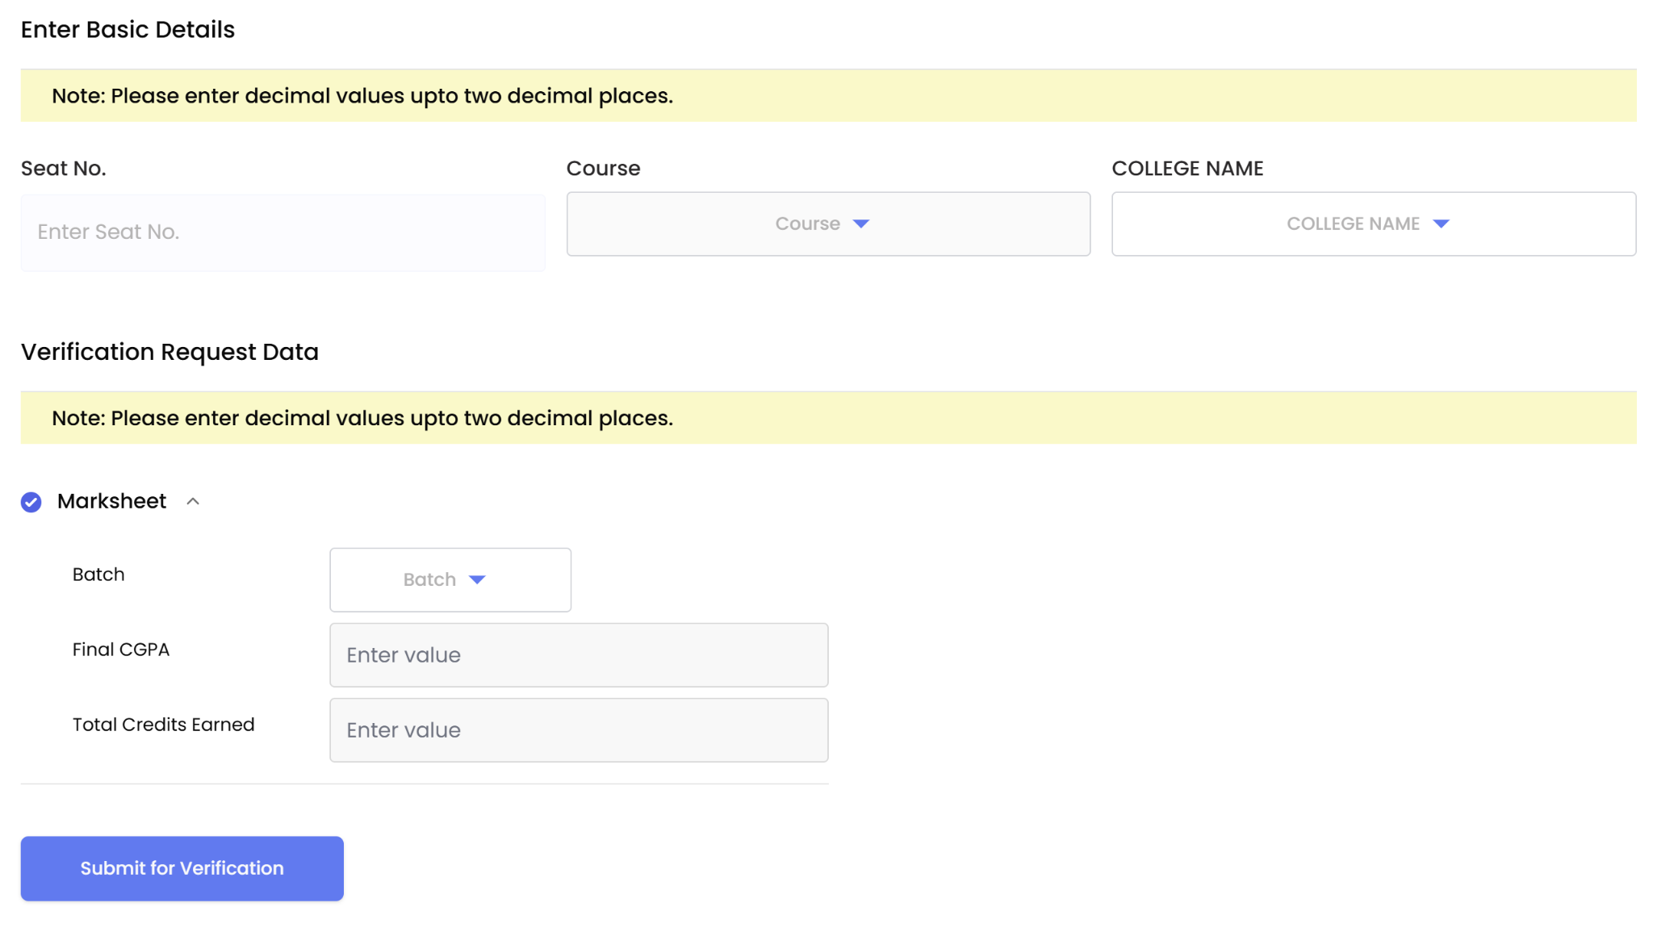

- Spacing can be adjusted in a manner that the entire screen is visible without having to scroll

